library(tm)

> library(rvest)

> library(XML)

> library(magrittr)

> # Review extraction

> url <- "https://www.amazon.in/dp/B077PWJQZM#customerReviews"

> Glacial <- NULL

> for(i in 1:10){

+ murl <- read_html(as.character(paste(url,i,sep = "=")))

+ rev <- murl%>%

+ html_nodes(".review-text")%>%

+ html_text()

+ Glacial <- c(Glacial,rev)

+ }

> write.table(Glacial,"Glacial.txt",row.names = F)

>

> OnePlus8 <- unique(readLines("Glacial.txt"))

>

> #cleaning https://

> df_OnePlus8 <- gsub(pattern = "http.*",replacement = "",x=OnePlus8 )

> df_OnePlus8 <- gsub("http.","",df_OnePlus8 )

> df_OnePlus8 <- gsub("#.*","",df_OnePlus8 )

> df_OnePlus8 <- gsub("@.*","",df_OnePlus8 )

>

> library(textcat)

> table(textcat(df_OnePlus8 ))

english manx norwegian ukrainian-koi8_r

8 1 1 1

> df_OnePlus8 [which(textcat(df_OnePlus8 )=="norwegian")]

[1] "\""

> consider <- c(which(textcat(df_OnePlus8 )!="norwegian"))

> df_OnePlus8 <- df_OnePlus8 [consider]

>

#stopwords

> stop <- readLines(file.choose())

> Glacial_corp <- Corpus(VectorSource(df_OnePlus8 ))

> Glacial_corp <- tm_map(Glacial_corp,removePunctuation)

Warning message:

In tm_map.SimpleCorpus(Glacial_corp, removePunctuation) :

transformation drops documents

> Glacial_corp <- tm_map(Glacial_corp,removeWords,stop)

In addition: Warning message:

In gsub(sprintf("(*UCP)\\b(%s)\\b", paste(sort(words, decreasing = TRUE), :

PCRE pattern compilation error

'unmatched closing parenthesis'

at ')| Great phone!Gaming performance is so great, device don't get heat up at all even at high settings!I played PUBG Mobile and details it provides were so exciting and make it feel real. Shadows of tree,stones, mud, etc. If you have small hands don't buy it for gaming, don't feel comfortable with small hands.Camera is good, can't say it is awesome!Battery life is great too, charge too fast!UI is as expected stock android, some pre-installed third party apps were also installed, you can uninstall all of them except Netflix.The back cover they provide is loose and cheap. Have to buy a new better one!Over all a great phone!Cheers! :)| Great phone!Gaming performance is so great, device don't get heat up at all even at high settings!I played PUBG Mobile and details it provides were so exciting and make it feel real. Shadows of tree,stones, mud, etc. If you have small hands don't buy it for gaming, don't feel comfortable w [... truncated]

> Glacial_corp <- tm_map(Glacial_corp,stripWhitespace)

Warning message:

In tm_map.SimpleCorpus(Glacial_corp, stripWhitespace) :

transformation drops documents

> mytxt = as.data.frame(inspect(Glacial_corp))

<<SimpleCorpus>>

Metadata: corpus specific: 1, document level (indexed): 0

Content: documents: 10

[1] x

[2] Hell man Im a oneplus fan till i buy this mobileCamera of this phone is completely worse before i was using oneplus 6 op6 camera is much better when compared with op8and important point to note that this phone does not even compete with my moms phone samsung a50s which is 15k rs phoneLastly if you dont trust reviews on thisKindly reach me out atI will provide you the originals picturesbecause i have wasted 40k not let you guys to wasteNote i have seen all reviews in youtubebut all will say it is bit bad but it is completely bad

[3] Read more

[4] I changed OnePlus 8 4 times Due to something or the other defects like headache giving screens line marks at the back of the body etc as its expensivePhone boxes were puffed torned some displays were dull if noticed closely more warm and yellowish No control by OnePlus on this People go nuts like wow what a display not realizing that they are being given inferior quality displays of SamsungI hope I really hope people strive for perfection to really understand and get what they are paying for by controlling their excitements a bit and forward stronger feedbacks as I believe I was listened and Amazon India did helped me tooMy 5th device came altogether from a different location excellent box phone built and display feels more broader even with same dimensions no two parallel lines design or defect at the back its clean and curvy like OnePlus 8 8gb variant mine is the 6gb one Screen display is still more warm which I didnt want but colors are very punchy and clearly shows the display is far better than previous returned devices1st OnePlus 8 8gb Had a very long permanent line mark at the back of the body if looked closely2nd OnePlus 8 8gb Displays blue light filter had issues Im sure as it gave me headache in seconds eye strain as well3rd OnePlus 8 6gb 2 parallel lines on edges of the back body if the device was tilted a little was like a dent kind of design or defect I believe though this one had the best display even than the 5th one that Im keeping and more smoother 90 HZ4th OnePlus 8 6gb 2 parallel lines were again there so I thought its normal and was okay with it but display was yellowish and dull playing pubg with graphics optimization made the game look more ugly in extreme hd settings hdr sucks Looking at Images on articles etc were looking just good5th OnePlus 8 6gb variant As told above there are no 2 parallel lines punchy colors not dull and very good display however still yellowish in large part of the screen and whitish around above and right left edges of the screen in vivid mode I did noticed in some displays it was not this warm I also noticed vivid mode was nicer and whiter in previous devices than this one whether they were dull or notI also know screen being yellowish a bit makes video viewing an amazing experience to make it more natural for skin color etc But should be less and corrected with all the flaws mentioned However Im tierd and somewhat satisfied but will want OnePlus to correct if possible with software update without compromising any quality of the displayIts said that Apple never compromises on quality they even delay their production if they find any imperfections I dont like iOS or use Apple though OnePlus should do like thisNot happy at all with this kind of support I noticed paying more when I got the 8gb one was really like getting better qalutiy made device the first one if the issue mentioned wasnt there This shouldnt be the case as this leads to disappointment and all variants should be given the same attentionperfection with just internal hardware changesOnePlus 8 will be my first and last device for a short period of time Will look for a brand who cares 3 out of 5

[5] Great phoneGaming performance is so great device dont get heat up at all even at high settingsI played PUBG Mobile and details it provides were so exciting and make it feel real Shadows of treestones mud etc If you have small hands dont buy it for gaming dont feel comfortable with small handsCamera is good cant say it is awesomeBattery life is great too charge too fastUI is as expected stock android some preinstalled third party apps were also installed you can uninstall all of them except NetflixThe back cover they provide is loose and cheap Have to buy a new better oneOver all a great phoneCheers

[6] On the first glance you will feel the premium quality of the Oneplus 8I have mentioned few good and bad points for quick understanding for every buyer Good Very good build qualityVivid displayExcellent performance and softwareSolid battery lifeDecent camera performanceChic designConsistent performanceOxygen OS is blissClassleading displayBadNo IP rating or wireless chargingLowlight video could be betterBasic cameras setup

[7] I have bought one plus 8 just 3 days back and now i am facing multiple issues like battery backup i am getting for just 34 hours of screen on time also facing issues with mobile hotspot as when i am connecting it with my laptop its getting reconnecting again and again however when i am conneting another device hotspot with the same network its working also its getting heat every time often i use lite application like facebook whtsapp no have apps or games are there i have tried to contact one plus support on call whtsapp and chat but there is no response from there side

[8] Camera quality is worst than OnePlus 6T

[9] Badly Heating Issue

[10] Great phone Amazon delivers it within 10 hours of ordering really happy therePros Beast performanceGreat battery LifeBrilliant ScreenFluid 90hzAnd blazing fast oxygen os5gConsCamera have a 2megapixel camera for the sake of having 3 camera on the backRest of the camera are only averageHopefully upadates can fix that and given one plus history I think they willCurved screen cause accidental touches and most covers cant cover phone fully in the front due to display Hence its prone to break more than regular flat screen phone like 7tHave a little bit of weight due to larger batteryPrincing is highly agressive but could have provided wireless charging and headphone jackIn the same priceOverall good phone if you want a future proof phone but this eyes closedBut if you are on a budget 7t can mostly get you there with better camera and almost as fast snapdragon 855plusChoose wisely

> #TDM

> Glacial_tdm <- TermDocumentMatrix(Glacial_corp)

>

> #convert tdm to dtm

> Glacial_dtm <- t(Glacial_tdm)

> rowtotals <- apply(Glacial_dtm,1,sum)

> Glacial_dtm2 <- Glacial_dtm[rowtotals>3,]

> Glacial_dtm2$dimnames$Terms

[1] "15k" "40k" "a50s"

[4] "all" "ati" "bad"

[7] "before" "better" "bit"

[10] "but" "buy" "camera"

[13] "compared" "compete" "completely"

[16] "does" "dont" "even"

[19] "fan" "guys" "have"

[22] "hell" "important" "let"

[25] "man" "mobilecamera" "moms"

[28] "much" "not" "note"

[31] "oneplus" "op6" "op8and"

[34] "originals" "out" "phone"

[37] "phonelastly" "picturesbecause" "point"

[40] "provide" "reach" "reviews"

[43] "samsung" "say" "seen"

[46] "that" "the" "this"

[49] "thiskindly" "till" "trust"

[52] "using" "was" "wasted"

[55] "wastenote" "when" "which"

[58] "will" "with" "worse"

[61] "you" "youtubebut" "more"

[64] "read" "5th" "6gb"

[67] "8gb" "above" "again"

[70] "also" "altogether" "amazing"

[73] "amazon" "and" "any"

[76] "apple" "are" "around"

[79] "articles" "attentionperfection" "back"

[82] "being" "believe" "best"

[85] "blue" "body" "box"

[88] "boxes" "brand" "broader"

[91] "built" "came" "cares"

[94] "case" "changed" "changesoneplus"

[97] "clean" "clearly" "closely"

[100] "closely2nd" "color" "colors"

[103] "compromises" "compromising" "control"

[106] "controlling" "correct" "corrected"

[109] "curvy" "defect" "defects"

[112] "delay" "dent" "design"

[115] "device" "devices" "devices1st"

[118] "did" "didnt" "different"

[121] "dimensions" "disappointment" "display"

[124] "displayits" "displays" "due"

[127] "dull" "edges" "etc"

[130] "excellent" "excitements" "expensivephone"

[133] "experience" "extreme" "eye"

[136] "far" "feedbacks" "feels"

[139] "filter" "find" "first"

[142] "flaws" "for" "forward"

[145] "from" "game" "gave"

[148] "get" "getting" "given"

[151] "giving" "good" "good5th"

[154] "got" "graphics" "had"

[157] "happy" "hardware" "hdr"

[160] "headache" "helped" "hope"

[163] "however" "hz4th" "images"

[166] "imperfections" "india" "inferior"

[169] "internal" "ios" "issue"

[172] "issues" "its" "just"

[175] "keeping" "kind" "know"

[178] "large" "last" "leads"

[181] "left" "less" "light"

[184] "like" "line" "lines"

[187] "listened" "little" "location"

[190] "long" "look" "looked"

[193] "looking" "made" "make"

[196] "makes" "mark" "marks"

[199] "mentioned" "mine" "mode"

[202] "natural" "never" "nicer"

[205] "normal" "noti" "noticed"

[208] "nuts" "okay" "one"

[211] "optimization" "other" "parallel"

[214] "part" "paying" "people"

[217] "perfection" "period" "permanent"

[220] "playing" "possible" "previous"

[223] "production" "pubg" "puffed"

[226] "punchy" "qalutiy" "quality"

[229] "realizing" "really" "returned"

[232] "right" "said" "same"

[235] "samsungi" "satisfied" "screen"

[238] "screens" "seconds" "settings"

[241] "short" "should" "shouldnt"

[244] "shows" "skin" "smoother"

[247] "software" "some" "something"

[250] "somewhat" "still" "strain"

[253] "strive" "stronger" "sucks"

[256] "support" "sure" "than"

[259] "their" "there" "they"

[262] "thisnot" "though" "thought"

[265] "tierd" "tilted" "time"

[268] "times" "told" "toomy"

[271] "torned" "two" "ugly"

[274] "understand" "update" "use"

[277] "variant" "variants" "very"

[280] "video" "viewing" "vivid"

[283] "want" "warm" "wasnt"

[286] "well3rd" "were" "what"

[289] "whether" "whiter" "whitish"

[292] "who" "without" "wow"

[295] "yellowish" "android" "apps"

[298] "awesomebattery" "can" "cant"

[301] "charge" "cheap" "comfortable"

[304] "cover" "details" "except"

[307] "exciting" "expected" "fastui"

[310] "feel" "gaming" "great"

[313] "hands" "handscamera" "heat"

[316] "high" "installed" "life"

[319] "loose" "mobile" "mud"

[322] "netflixthe" "new" "oneover"

[325] "party" "performance" "phonecheers"

[328] "phonegaming" "played" "preinstalled"

[331] "provides" "real" "settingsi"

[334] "shadows" "small" "stock"

[337] "them" "third" "too"

[340] "treestones" "uninstall" "battery"

[343] "betterbasic" "blissclassleading" "build"

[346] "buyer" "cameras" "charginglowlight"

[349] "could" "designconsistent" "displaybadno"

[352] "displayexcellent" "every" "few"

[355] "glance" "lifedecent" "performancechic"

[358] "performanceoxygen" "points" "premium"

[361] "qualityvivid" "quick" "rating"

[364] "setup" "softwaresolid" "understanding"

[367] "wireless" "another" "application"

[370] "backup" "bought" "call"

[373] "chat" "connecting" "conneting"

[376] "contact" "days" "facebook"

[379] "facing" "games" "hotspot"

[382] "hours" "laptop" "lite"

[385] "multiple" "network" "now"

[388] "often" "plus" "reconnecting"

[391] "response" "side" "tried"

[394] "whtsapp" "working" "worst"

[397] "badly" "heating" "2megapixel"

[400] "7thave" "855pluschoose" "90hzand"

[403] "accidental" "agressive" "almost"

[406] "averagehopefully" "backrest" "batteryprincing"

[409] "beast" "blazing" "break"

[412] "budget" "cause" "charging"

[415] "closedbut" "covers" "delivers"

[418] "eyes" "fast" "fix"

[421] "flat" "front" "fully"

[424] "future" "having" "headphone"

[427] "hence" "highly" "history"

[430] "jackin" "larger" "lifebrilliant"

[433] "most" "mostly" "only"

[436] "ordering" "os5gconscamera" "oxygen"

[439] "performancegreat" "priceoverall" "prone"

[442] "proof" "provided" "regular"

[445] "sake" "screenfluid" "snapdragon"

[448] "therepros" "think" "touches"

[451] "upadates" "weight" "willcurved"

[454] "wisely" "within"

>

> #LDA

> library(topicmodels)

> Glacial_LDA <- LDA(x=Glacial_dtm2,10)

> Glacial_LDA_terms <- terms(Glacial_LDA,5)

> Glacial_LDA_terms

Topic 1 Topic 2 Topic 3 Topic 4 Topic 5 Topic 6 Topic 7 Topic 8

[1,] "the" "camera" "have" "phone" "have" "great" "phone" "than"

[2,] "oneplus" "oneplus" "with" "the" "for" "all" "this" "oneplus"

[3,] "more" "quality" "and" "camera" "the" "dont" "you" "quality"

[4,] "and" "than" "getting" "and" "and" "and" "all" "camera"

[5,] "for" "worst" "its" "you" "with" "buy" "bad" "worst"

Topic 9 Topic 10

[1,] "and" "the"

[2,] "the" "good"

[3,] "was" "and"

[4,] "like" "for"

[5,] "with" "bad"

> topics <- terms(Glacial_LDA)

> table <- table(names(topics),unlist(topics))

> library(cluster)

> library(dendextend)

> cluster <- hclust(dist(table),method = "ward.D2")

> colr <- color_branches(cluster,k=4)

> plot(colr)

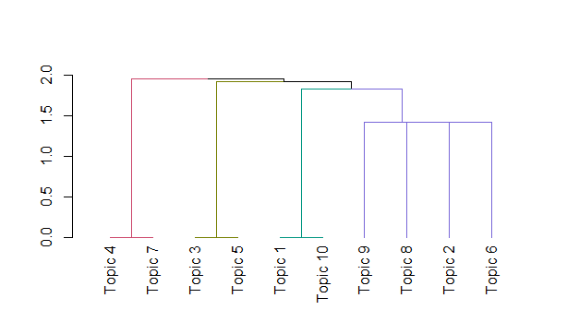

#NLP

> library(syuzhet)

> Glacials <- get_sentences(df_OnePlus8 )

> class(Glacials)

[1] "character"

> #sentiment analysis

> sentiments <- c("syuzhet","afinn","bing","nrc","custom")

> A <- NULL

> sentimentlist <- NULL

> for(i in sentiments[1:4]){

+ sentimentlist[[i]] <- get_sentiment(Glacials,method = i)

+ A[[i]] <- table(get_sentiment(Glacials,method = i))

+ }

> A

$syuzhet

-0.8 -0.75 -0.5 -0.35 -0.25 -0.15 -0.1 0 0.05 0.15 0.45 0.5 0.6 0.75

1 2 3 1 2 1 1 10 1 1 1 4 1 1

0.9 1 1.05 1.1 1.15 1.3 1.35 1.5 1.6 1.65 1.75 1.8 2.05 2.9

1 2 1 1 1 1 1 2 1 2 2 1 1 1

$afinn

-4 -3 -2 -1 0 1 2 3 4 5 6 7

1 5 2 4 12 3 6 6 3 2 2 2

$bing

-2 -1 0 1 2 3 4

3 7 13 17 4 2 2

$nrc

-3 -1 0 1 2 3

1 8 27 9 2 1

> sentimentlist

$syuzhet

[1] 0.00 -0.80 0.45 1.15 1.05 -0.75 -0.35 0.00 0.00 -0.50 -0.25 0.00 0.00

[14] 2.90 1.65 -0.15 1.80 0.75 1.10 -0.50 0.60 0.50 1.75 1.30 0.15 0.00

[27] 1.00 0.00 0.50 0.90 1.00 -0.25 0.50 1.35 0.50 0.00 0.05 1.60 1.50

[40] 0.00 0.00 1.75 1.65 -0.50 -0.75 1.50 -0.10 2.05

$afinn

[1] 0 -4 2 2 0 -3 -3 0 0 -1 -1 -1 1 4 3 1 1 -2 5 0 4 2 7 4 -2 0

[27] 2 0 3 3 3 0 2 7 3 0 -3 2 5 0 0 -1 3 -3 -3 6 0 6

$bing

[1] 0 -1 0 1 1 -1 -1 0 0 -2 0 0 1 3 2 -1 3 1 1 -1 1 1 2 1 1 0

[27] 0 0 1 1 1 0 1 2 2 0 -2 1 1 0 0 1 1 -1 -2 4 -1 4

$nrc

[1] 0 -1 0 1 0 -1 0 0 0 0 -1 0 -1 3 1 -3 1 0 0 0 1 0 2 0 0 0

[27] 0 0 0 0 2 0 -1 1 -1 0 0 0 0 0 0 1 1 0 -1 -1 1 1

>#plot for NRC

> plot(sentimentlist$nrc,type = "l",main = "NRC plot")

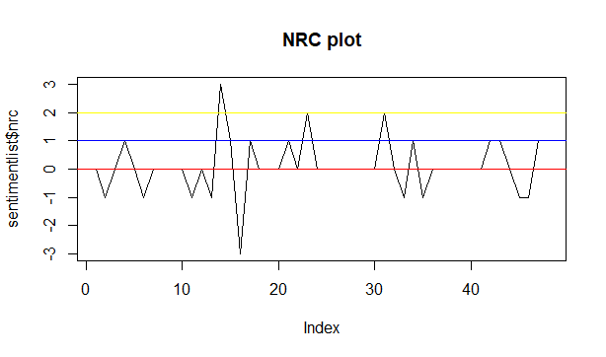

# sentences with negative emotion values

> negative <- sentimentlist$nrc[which.min(sentimentlist$nrc)]

> Glacials[which(sentimentlist$nrc==negative)]

[1] "Screen display is still more warm which I didn't want but colors are very punchy and clearly shows the display is far better than previous returned devices.1st OnePlus 8 8gb - Had a very long permanent line mark at the back of the body if looked closely.2nd OnePlus 8 8gb - Display's blue light filter had issues I'm sure as it gave me headache in seconds, eye strain as well.3rd OnePlus 8 6gb - 2 parallel lines on edges of the back body if the device was tilted a little, was like a dent kind of design or defect (I believe though this one had the best display even than the 5th one that I'm keeping and more smoother 90 HZ).4th OnePlus 8 6gb - 2 parallel lines were again there so I thought it's normal and was okay with it, but display was yellowish and dull, playing pubg with graphics optimization made the game look more ugly in extreme hd settings (hdr sucks)."

>> #sentences with positive emotions values

> positive <- sentimentlist$nrc[which.max(sentimentlist$nrc)]

> Glacials[which(sentimentlist$nrc==positive)]

[1] "I hope I really hope people strive for perfection to really understand and get what they are paying for by controlling their excitements a bit and forward stronger feedbacks, as I believe I was listened and Amazon India did helped me too."

>> #emotion plot

> nrc_data <- get_nrc_sentiment(Glacials)

> barplot(sort(colSums(prop.table(nrc_data[,1:8]))),cex.names = 0.8,col = 1:8)

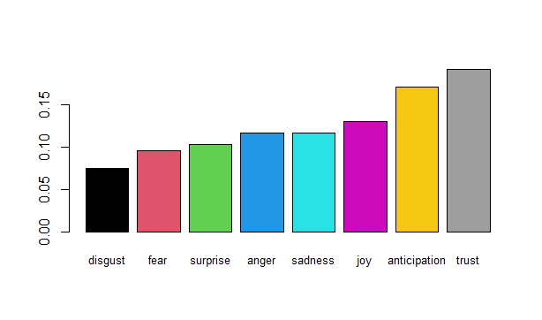

> #word cloud

> library(tm)

> library(SnowballC)

> library(wordcloud)

> library(RColorBrewer)

>

> freq <- rowSums(as.matrix(Glacial_tdm))

> length(freq)

[1] 455

order <- order(freq,decreasing = TRUE)

> head(freq)

15k 40k a50s all ati bad

1 1 1 8 1 3

> data_frame <- data.frame(word=names(freq),freq=freq)

> data_frame <- data_frame[-8,]

> wordcloud(words = data_frame$word,freq = data_frame$freq,min.freq = 2,max.words = 200,random.order = F,colors = brewer.pal(10,"Dark2"))

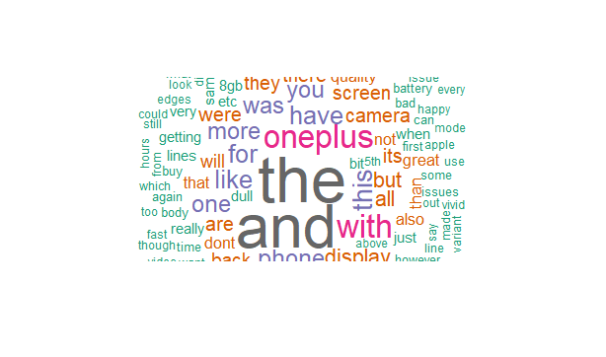

Warning message:

In brewer.pal(10, "Dark2") :

n too large, allowed maximum for palette Dark2 is 8

Returning the palette you asked for with that many colors

> #Operations on term-document matrix

> findFreqTerms(Glacial_dtm,lowfreq = 5)

[1] "all" "better" "but" "camera" "dont" "even" "have" "not"

[9] "oneplus" "phone" "that" "the" "this" "was" "will" "with"

[17] "you" "more" "also" "and" "are" "back" "device" "display"

[25] "for" "good" "its" "like" "one" "quality" "screen" "than"

[33] "there" "they" "were" "great"

> findAssocs(Glacial_dtm,terms = "fast",corlimit = 0.3)

$fast

2megapixel 7thave 855pluschoose 90hzand

1.00 1.00 1.00 1.00

accidental agressive almost averagehopefully

1.00 1.00 1.00 1.00

backrest batteryprincing beast blazing

1.00 1.00 1.00 1.00

break budget cause charging

1.00 1.00 1.00 1.00

closedbut covers delivers eyes

1.00 1.00 1.00 1.00

fix flat front fully

1.00 1.00 1.00 1.00

future having headphone hence

1.00 1.00 1.00 1.00

highly history jackin larger

1.00 1.00 1.00 1.00

lifebrilliant most mostly only

1.00 1.00 1.00 1.00

ordering os5gconscamera oxygen performancegreat

1.00 1.00 1.00 1.00

priceoverall prone proof provided

1.00 1.00 1.00 1.00

regular sake screenfluid snapdragon

1.00 1.00 1.00 1.00

therepros think touches upadates

1.00 1.00 1.00 1.00

weight willcurved wisely within

1.00 1.00 1.00 1.00

camera due can phone

0.93 0.88 0.88 0.83

amazon happy little cant

0.67 0.67 0.67 0.67

cover could wireless hours

0.67 0.67 0.67 0.67

you get battery given

0.57 0.51 0.51 0.36

want plus are screen

0.36 0.36 0.34 0.34

but bit have same

0.32 0.30 0.30 0.30

> head(data_frame,10)

word freq

15k 15k 1

40k 40k 1

a50s a50s 1

all all 8

ati ati 1

bad bad 3

before before 1

bit bit 4

but but 8

buy buy 3

barplot(data_frame[1:10,]$freq, las = 2,

+ names.arg = data_frame[1:10,]$word,

+ col ="lightblue", main ="Most frequent words",

+ ylab = "Word frequencies")

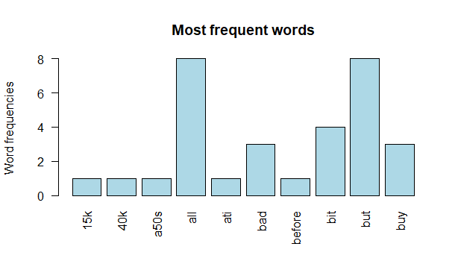

#Feature extraction using n-grams************

library(wordcloud)

library(qdap)

library(RColorBrewer)

library(RWeka)

library(ngram)

> mytxt = as.data.frame(inspect(Glacial_corp))

<<SimpleCorpus>>

Metadata: corpus specific: 1, document level (indexed): 0

Content: documents: 10

[1] x

[2] Hell man Im a oneplus fan till i buy this mobileCamera of this phone is completely worse before i was using oneplus 6 op6 camera is much better when compared with op8and important point to note that this phone does not even compete with my moms phone samsung a50s which is 15k rs phoneLastly if you dont trust reviews on thisKindly reach me out atI will provide you the originals picturesbecause i have wasted 40k not let you guys to wasteNote i have seen all reviews in youtubebut all will say it is bit bad but it is completely bad

[3] Read more

[4] I changed OnePlus 8 4 times Due to something or the other defects like headache giving screens line marks at the back of the body etc as its expensivePhone boxes were puffed torned some displays were dull if noticed closely more warm and yellowish No control by OnePlus on this People go nuts like wow what a display not realizing that they are being given inferior quality displays of SamsungI hope I really hope people strive for perfection to really understand and get what they are paying for by controlling their excitements a bit and forward stronger feedbacks as I believe I was listened and Amazon India did helped me tooMy 5th device came altogether from a different location excellent box phone built and display feels more broader even with same dimensions no two parallel lines design or defect at the back its clean and curvy like OnePlus 8 8gb variant mine is the 6gb one Screen display is still more warm which I didnt want but colors are very punchy and clearly shows the display is far better than previous returned devices1st OnePlus 8 8gb Had a very long permanent line mark at the back of the body if looked closely2nd OnePlus 8 8gb Displays blue light filter had issues Im sure as it gave me headache in seconds eye strain as well3rd OnePlus 8 6gb 2 parallel lines on edges of the back body if the device was tilted a little was like a dent kind of design or defect I believe though this one had the best display even than the 5th one that Im keeping and more smoother 90 HZ4th OnePlus 8 6gb 2 parallel lines were again there so I thought its normal and was okay with it but display was yellowish and dull playing pubg with graphics optimization made the game look more ugly in extreme hd settings hdr sucks Looking at Images on articles etc were looking just good5th OnePlus 8 6gb variant As told above there are no 2 parallel lines punchy colors not dull and very good display however still yellowish in large part of the screen and whitish around above and right left edges of the screen in vivid mode I did noticed in some displays it was not this warm I also noticed vivid mode was nicer and whiter in previous devices than this one whether they were dull or notI also know screen being yellowish a bit makes video viewing an amazing experience to make it more natural for skin color etc But should be less and corrected with all the flaws mentioned However Im tierd and somewhat satisfied but will want OnePlus to correct if possible with software update without compromising any quality of the displayIts said that Apple never compromises on quality they even delay their production if they find any imperfections I dont like iOS or use Apple though OnePlus should do like thisNot happy at all with this kind of support I noticed paying more when I got the 8gb one was really like getting better qalutiy made device the first one if the issue mentioned wasnt there This shouldnt be the case as this leads to disappointment and all variants should be given the same attentionperfection with just internal hardware changesOnePlus 8 will be my first and last device for a short period of time Will look for a brand who cares 3 out of 5

[5] Great phoneGaming performance is so great device dont get heat up at all even at high settingsI played PUBG Mobile and details it provides were so exciting and make it feel real Shadows of treestones mud etc If you have small hands dont buy it for gaming dont feel comfortable with small handsCamera is good cant say it is awesomeBattery life is great too charge too fastUI is as expected stock android some preinstalled third party apps were also installed you can uninstall all of them except NetflixThe back cover they provide is loose and cheap Have to buy a new better oneOver all a great phoneCheers

[6] On the first glance you will feel the premium quality of the Oneplus 8I have mentioned few good and bad points for quick understanding for every buyer Good Very good build qualityVivid displayExcellent performance and softwareSolid battery lifeDecent camera performanceChic designConsistent performanceOxygen OS is blissClassleading displayBadNo IP rating or wireless chargingLowlight video could be betterBasic cameras setup

[7] I have bought one plus 8 just 3 days back and now i am facing multiple issues like battery backup i am getting for just 34 hours of screen on time also facing issues with mobile hotspot as when i am connecting it with my laptop its getting reconnecting again and again however when i am conneting another device hotspot with the same network its working also its getting heat every time often i use lite application like facebook whtsapp no have apps or games are there i have tried to contact one plus support on call whtsapp and chat but there is no response from there side

[8] Camera quality is worst than OnePlus 6T

[9] Badly Heating Issue

[10] Great phone Amazon delivers it within 10 hours of ordering really happy therePros Beast performanceGreat battery LifeBrilliant ScreenFluid 90hzAnd blazing fast oxygen os5gConsCamera have a 2megapixel camera for the sake of having 3 camera on the backRest of the camera are only averageHopefully upadates can fix that and given one plus history I think they willCurved screen cause accidental touches and most covers cant cover phone fully in the front due to display Hence its prone to break more than regular flat screen phone like 7tHave a little bit of weight due to larger batteryPrincing is highly agressive but could have provided wireless charging and headphone jackIn the same priceOverall good phone if you want a future proof phone but this eyes closedBut if you are on a budget 7t can mostly get you there with better camera and almost as fast snapdragon 855plusChoose wisely

>get.ngrams(ngram(as.character(mytxt),3))

"some displays it"

[4] "LifeBrilliant ScreenFluid 90hzAnd"

[5] "oneplus fan till"

[6] "prone to break"

[7] "chargingLowlight video could"

[8] "also know screen"

[9] "betterBasic cameras setup\","

[10] "cheap Have to"

[11] "experience to make"

my<-get.ngrams(ngram(as.character(mytxt),3))

#************Bigram******************

>

> minfreq_bigram<-2

> bitoken <- NGramTokenizer(Glacial_corp, Weka_control(min=2,max=2))

> two_word <- data.frame(table(bitoken))

> sort_two <- two_word[order(two_word$Freq,decreasing=TRUE),]

> wordcloud(sort_two$bitoken,sort_two$Freq,random.order=FALSE,scale =

+ c(2,0.35),min.freq = minfreq_bigram,colors = brewer.pal(8,"Dark2"),max.words=150)

>

